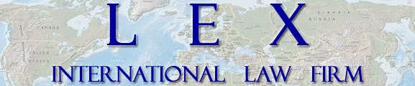

**www.lex-international.com**

**lex@lex-international.com**

**lex1usa@aol.com**

**USA**

International Place

100 S.E. 2nd St. #2222

Miami, Florida 33131 USA

Tel : +1 (305) 358-9990

Fax : +1 (305) 358-9997

**America:**

**Rusia**

Richwise – 3nd Floor

7rd Line 76, Basil Island

St-Petersburg, 199178 Russia

Tel: +7 (812) 323-9086

**Belgica**

475, Avenue Louise

B-1050 Bruselas

Belgica

Tel: +32 491 940 149

Fax: +32 2 791 53 85

**Luxemburgo**

17, Boulevard Royal

L-2449

Luxembourg

GD Luxembourg

Tel: +352 274 404

Fax: +352 246 119 19

**Canada**

1, Carré Westmount

Bureau 1001

Westmount (Québec) Canada H3Z 2P9

Tel: +1 (514) 396 6608

Fax: +1 (514) 940 0645

**Brasil**

CAS Ốleo Visas Legalização de

Documentos ltda.

Matriz: Rua da Assembléia 19-5° andar – Centro – CEP 20011-001 – Rio de Janeiro/RJ - Brasil

**Abogados Principales U.S.**

Lucius SMEJDA (USA, Canada)

Joseph B. McFARLAND (USA)

Antonio R. ZAMORA (USA)

Maxim ISTOMIN (Rusia, USA)

Elke ROLFF (USA, Suiza)

**Nuestros Servicios**

Impuestos

Negocios

Inversiones

Corporaciones

Finca raiz

Finanzas y Planeacion

Practica Notarial Internacional

**Republica Dominicana**

Ensanche Piantini, Calle  Max.Henriquez Urena. Esq.Freddy Prestol.  Plaza Morichal Local 11c Piso 3. Santo Domingo. 10127

**Principal Int’l Network Attorneys**

Eric J.P CITREY (France)

Vladimir A. TROITSKIY (Russia)

Evgeny V. GOLOVANOV (Russia)

Olivier HANCE (Belgium)

Aleksandr SMIRNOV (Russia)

Jacques ETHIER (Can)

Carlos AUD (Brazil)

**Oficina Principal U.S.**

**Nuestros Servicios**

Impuestos

Negocios

Inversiones

Corporaciones

Finca Raíz

Finanzas y Planeación

Práctica Notarial Internacional

**Abogados Principales**

Lucius SMEJDA (USA, Canada)

Joseph B. McFARLAND (USA)

Antonio R. ZAMORA (USA)

Elke ROLFF (USA, Suiza)

Maxim ISTOMIN (Rusia, USA)

**Juristas**

Susanne LEONE (Alemania)

Evgeny GOLOVANOV (Rusia)

Jasmin WELKER (Alemania)

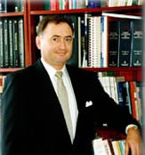**LUCIUS SMEJDA**

PRINCIPAL

**Asociación de Abogados:** USA: New York, Florida and Illinois; Canada: Alberta; The Supreme Court of the United States; The United States Tax Court and numerous other courts.

**Notario Internacional:** Florida (Equivalente a Notario Civil)

**Idiomas:** Ingles, Frances, Aleman, Espanol y Ruso basicos..

**Educacion:** Northwestern University (B.A., *summa cum laude*, 1968); Columbia University (J.D., 1972); New York University (LL.M. in Taxation, 1974); The Hague Academy of International Law (Holanda); The Sorbonne (Paris, Francia); University of Strasbourg (Francia).

**Publicaciones:** "The Supplemental Register: Does It Fulfill Its Functions Internationally and Domestically?", Trademark Reporter 1972; "The New United States-Canada Income Tax Treaty", International Estate Planning - ABA 1981; "The Proposed Canadian Tax Treaty; Trends and Policies", International Tax Journal 1981; "U.S. Tax Considerations for Foreign Investments in U.S. Portfolio Asset (Stocks, Bonds, Deposits, Commodities)”, “Taxation of Foreign Investors”, Florida Bar 1981; “Aperçu général des principaux impôts en matière d’Investissement Canadien dans la propriété fonçière Américaine”, Canadian Bar Association, (Montreal) 1983; “Notions élémentaires de planification commerciale et fiscale à l’usage d’entreprises françaises désirant s’établir aux Etats-Unis”, Chambre Nationale de la Restauration et de l’Hôtellerie 1982; “Major Restrictions on Foreign Investment in Canada”, Current Legal Issues in U.S./Canada Trade & Investment, (Florida Bar CLE Manual 1985); “U.S. Taxation of Corporations, Fiscalité Canada – Etats-Unis”, Laval University, Canada 1986; “Business Operations in Panama”, 1987 BNA Tax Management Portfolio; “Establishing and Managing a Canadian Business in Florida”, “Planning Considerations for Canadians Doing Business or Residing in Florida”, Quebec Forum 2000; “Structuring Repatriation of Profits, Interest and Dividends”, Florida Bar, 2001; “Acquisition & Financing of Real Estate Investments” French Notary Seminar 2002; “Planning Future Repatriations”, France-Florida Forum (Paris, 2002); “International Tax Planning”, Russian Symposium (St Petersburg, 2003); “Major US Laws & Practices re: International Business & Investments”, Barcelona Symposium (Barcelona, 2004): “Estonia – New Europe Gateway?” International Symposium (Miami, 2005); “Investing & Living in Florida: Tax & Legal Solutions”, Mondissimo convention (Paris, 2010); « Establishing and Managing a Canadian Business in Florida », Quebec-Florida Forum (Quebec, 2010); « U.S. Non-resident Taxation and Estate Planning », Quebec-Florida Forum (Quebec, 2010).

**Miembro de:**  International Bar Association; The New York Bar; The Florida Bar (Chair, International Law Section, 2004-2005); Canadian and American Bar Associations; Alberta Law Society; Canadian Tax Foundation; International Fiscal Association; Phi Beta Kappa; James Kent Circle; Harlan Fiske Stone; U.S. National Association of Civil Law Notaries.

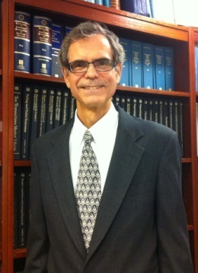

**JOSEPH B. McFARLAND**  **CONSEJERO**

**Asociacion de Abogados**: Florida, New York.

**Idiomas**: Frances, Aleman y Espaňol.

**Educacion**: University Of Florida (LL.M. in Taxation 1992); New York Law School (J.D. 1982) ; Law Review, Johns Hopkins University, SAIS (School of Advanced International Studies) (M.A. Int’l Economics and Latin American Studies 1976); Princeton University (B.A. History 1974)

**Publicaciones**: “The Case Management Conference: Tune-Up Needed?” Florida Bar Journal (October 2001); “The Innocent Spouse Rule: Variation on a Theme,” Florida Bar Journal (February 1999); "The Medicaid Disability Trust” Co-author with Roger Bernstein, Florida Bar Journal (December 1995); “The U.S. - Canada Income Tax Treaty: The Revised Protocol,” Florida Bar Journal (August 1995); “The Qualified Domestic Trust,” 7 Florida Journal of International Law 119 (Spring 1992); “Tax Reform Comes to the U.S. Virgin Islands,” The International Business Lawyer, (July/August 1988); “Counseling the International Client on Alternative Countries of Residence: Costa Rica, Dominican Republic, Mexico,” International Law Quarterly, Florida Bar publication(October 1987).

**Miembro**: Chairman, Unlicensed Practice of Law (UPL) Committee (Orlando–9B), Florida Bar (2006 - 2010); Vice-President, German-American Business Council of Tampa Bay (1997–2000); Board Member, French-American Business Council of West Florida (1999-2000); Adjunct Professor. of Law (International Taxation), Stetson University College of Law (1994); Chairman, European Union Subcom., Tampa Bay Int’l Business Council (1994–95); Executive Committee Member, Tampa Bay Int’l Business Council (1987-89), American Immigration Lawyers Association.

**Areas de Practica**: Transacciones Comerciales Internacionales; Derecho Fiscal; Derecho de Inmigracion; Pre-inmigracion y Estructuracion Corporativa y Fiscal; Derecho Corporativo y Contractual.

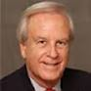**ANTONIO R. ZAMORA  
CONSEJERO**

**Admitido en la Asociacion de Abogados:** Florida, 1973.

**Idiomas:** Ingles, Espanol.

**Educacion:** Universidad de la Florida (B.A., Political Science, 1965); Certificado de Estudios Latino-Americanos, 1965); Universidad de Miami M.A., 1996 (Estudios Internacionales); Universidad de la Florida, J.D., 1973.

**Publicaciones:** “Andean Pact: Regulation of Foreign Investments”, Vol. 10, No. 1, International Lawyer, 1976; “Joint Real Estate Developments between Foreign Persons and U.S. Persons”, Real Estate Digest, 1980; “Cuba’ s New Foreign Investment Law: Better, Worse or the Same as Before?”, Focus Americas, February 1996; “Real Estate Investments in Cuba: Back to the Future”, Florida Journal of International Law, Fall 1997 (Published in 1999); “Foreign Investment in Cuba: A U.S. Perspective”, Probate & Property Magazine (ABA), November/December 2000; “Cuba’s Business Enterprises: How Business is Conducted on the Island”, Florida Journal of International Law, Spring 2003; “The Political Evolution of the Cuban-American Community of South Florida: 1959-2005”, The Wisconsin Symposium on Cuba, March 3-5, 2005; “How Cuba’s Legal System Will Adapt to a business Opening”, Latin Lawyer, July 2006; Cuba’s Real Estate Under Succession”, International Law Quarterly, The Florida Bar, Summer/Fall 2008; “Real Estate development in Cuba: Present and Future”, publisehed by Nova Southeastern University, ILSA Journal of International and Comparative Law, Summer 2009; “What I Learned About Cuba by Going to Cuba” a Cuba Libre Publication, 2013.

**Experiencia:** Vice-Presidente, City of Miami International Trade Board, 1985-1993; President, Miami Friends of Caribbean/Latin American Action, 1985-1987; Director and Legal Counsel, Cuabn-American National Foundation, 1982-1992; Vice-President, Official Chamber of Commerce and Venezuelan-American Industries, 1988-1990; trustee, Greater Miami Chamber of Commerce, 1984; President, Hispanic American Voters Education, Inc., 1983-1984; Secretary, Bay of Pig’s Veteran’s Association, 1983-1984; Founder and First Vice-President, Cuban American Bar Association, 1975; President, US/Cuba Legal Forum, Inc., 2000 to date; International Advisor, University of Florida College of Law, 2002 to date; President, Foundation of the Normalization of US/Cuba Relations, 2006-2008.

**Areas de Practica:** Derecho Internacional/Inversiones Extranjeras, Derecho Corporativo, Derecho Inmobiliario.

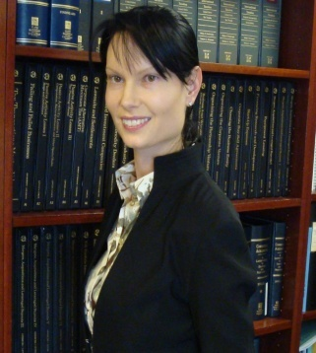**ELKE ROLFF  
CONSEJERO**

**Admitido al Colegio de Abogados**: Florida,USA; Suiza.

**Idiomas**: Alemán, Inglés, Italiano, Francés, Espaňol y Portugués básico.

**Educación**: Universidad de Zurich Facultad de Derecho, Zurich, Suiza (J.D.); Universidad de Miami Facultad de Derecho, Florida (J.D., cum laude).

**Publicaciones**: “Das Neueste zum Einwanderungsrecht” – Florida Sun (2004), “Florida mobil: Fuehrerscheine fuer Auslaender” – Florida Sun (2005), “J-1 Visum: Flexibel in Amerika” – Florida Sun, “Alterntiven zum H-1B Visum” – Florida Sun (2006), “Want to work in the USA?” publicado en Foreign Living, “Alles ganz legal” publicado en Florida Sun, Florida Sun Seminar Series in Germany: legal aspects of real estate investments in Florida (Speaker 2005 and 2006). “Clever den Nachlass planen” publicado en Florida Sun (2007), “Relativ unproblematish” publicado en Florida Sun Magazine, “Student or trainee in the U.S.” publicado en Foreign Living magazine,“An introduction to double taxation” publicado en Foreign Living,“Pension unter almen” publicado en Florida Sun, “Soziale Absicherung auf Amerikanisch” publicado en Florida Sun (2008). Foreign Investor’s Guide – Purchasing Real Property and Doing Business in the United States, Immigration for Real Estate Investors (book); La Clausola Arbitrale – Arbitration Clause (.it Italian Trade); “Current Immigration Rules and Practices in Canada and the U.S.”, Quebec-Florida Forum (Fort Lauderdale, 2011).

**Miembro**: Junta Directiva, Cámara de Comercio Anglo-americana; Colegio de Abogados de la Florida – Sección de Derecho Internacional; Director, Seminario de Certificación y Actualización de Derecho Internacional (2005); Director, Seminario sobre la Introducción de Transacciones Internacionales (2006); Asociación de Abogados de Inmigración (AILA); Director, Seminario sobre la Introducción de Transacciones Internacionales (2007); Co-director, Primera Conferencia Annual sobre Transacciones Comerciales Internacionales (2008).

**Areas de Práctica**: Transacciones comerciales internacionales e inversiones extranjeras; derecho de inmigración; planificacion tributaria y corporativa; derecho general corporativo y leyes de contrato.

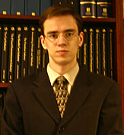

**MAXIM ISTOMIN**  **CONSEJERO**

**Asociacion de Abogados:** Florida and Russian Federation – Moscow (Practices in Russia)

**Idiomas:** Ingles, Ruso y Aleman Basico..

**Educacion:** Moscow State Pedagogical University, Russia (Civil Law Jurisdiction Law Degree, summa cum laude, 1998); Moscow State Academy of Law, Russia (Jurisprudence, 1999); Florida State University College of Law, Florida (J.D., cum laude, 2001).

**Experiencia:** Onyx Publishing, Moscow (1995-1997), Moscow State Court of Arbitration, Moscow (1996-1997), Investment Development and Legal Consulting Company (1997-1999), Florida State University School of Criminology (2000), College of Law (2001), Florida Department of State, Office of International Affairs (2001-2002), Bartolus, P.L. (200-2003), Florida State University – USAID (2003 - 2005).

**Miembro:** The Florida Bar; The International Law Section of the Florida Bar (Chair, Russia-Eurasian Committees of the International Law Section).

**Areas de Practica:** Derecho Internacional, Corporativo, Comercial y Notarial, Relaciones Gubernamentales.

**Conferencias:** Florida Bar Seminars 2002-2004; Russian Investment Symposium, 2003; International Symposium, 2005.

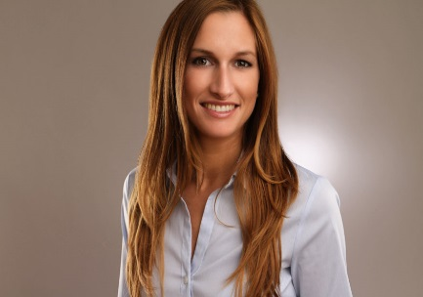

**SUSANNE LEONE   
JURISTA**

**Asociacion de Abogados:** Alemania; Florida (2017)

**Idiomas:** Aleman, Ingkles, Frances (conversacional)

**Educacion:** St. Thomas University School of Law, Miami, Florida,

Candidate for J.D. anticipated May 2017

Honors: St. Thomas University School of Law Merit Scholarship, 2016 –

Present, St. Thomas Legacy Award, Dean’s List Spring 2016

University of Augsburg, Germany, Second State Exam (J.D.) May 2014

**Experience:** Lex International Law Firm, P.A., Miami, Florida 12/8/14 - present

Jurist + German Lawyer

(International, contracts and corporate law)

HammersenS, Munich,Germany 09/01/14 – 11/07/14

Lawyer

(Business, corporate, employment law, bank and finance, compliance)

Coane and Associates, PLLC, Miami Beach, Florida Summer 2014

Intern

(Employment law and immigration)

Baur & Klein, P.A., Miami, Florida 01/02/14 – 04/01/14

Referendar

(Immigration, corporate, tax, estate and trust, investments, family law and real estate)

Seitz-Weckbach-Fackler, Augsburg, Germany 07/02/13 – 12/31/13

Referendar

(Tax, criminal, familiy, employment, inheritance, corporate, administrative law and litigation)

Sony Music Entertainment GmbH, Munich, Germany 04/01/13 – 07/01/13

Referendar

(Media, copyright, entertainment law and contracts)

**Practice Areas:** Derecho Internacional, Derecho Comercial y de Negocios, Contratos y Derecho Corporativo

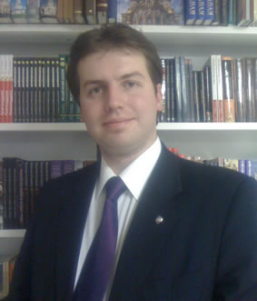**EVGENY V. GOLOVANOV  
JURISTA**

**Asociacion De Abogados:** Federacion Rusa – St Petersburg, Moscu (Practica en Rusia)

**Idiomas:** Ruso, Ingles, Aleman basico y Latin.

**Educacion:** St. Petersburg State University Law School, Rusia – International Law Jurisdiction Degree, (2005), Moscow State University of Foreign Relations (MGIMO) – International Law PhD program.

**Publicaciones:** Few aspects of totalitarian regimes in XXI century. Law School magazine (2002); Public science – Teaching guide (2007). The UN Security Council: the place and importance in the XXI century. POLITEKS political expertise. Vol.8. Number 2. St. Petersburg., 2011., Crisis in the approaches to reforming the UN Security Council. / / Political institutions in the world today. Materials of the Scientific Conference with International Participation 10 - December 11, 2010, St. Petersburg., 2010., Approaches to the UN Security Council reform: political and legal aspects. / / United Nations: Challenges and mechanisms. Collection of scientific papers. St. Petersburg., 2011, The problem of Kosovo in the context of the concept of universal security. / / Politics in texts - texts in politics: science is the history of ideas and doctrines. Materials of the International scientific conference, the 40th Anniversary of the Department of Social and Political History of the exercise of political science faculty of Moscow State University. MV University. 28-29 October 2011, Moscow, 2011., The crisis of universal security system: history, theory and practice. / / Politics in texts - texts in politics: science is the history of ideas and doctrines. Materials of the International scientific conference, the 40th Anniversary of the Department of Social and Political History of the exercise of political science faculty of Moscow State University. MV University. 28-29 October 2011, Moscow, 2011.

**Experiencia:** Executive secretary, United Nations Association Russia (from 2003), Professor of International law and Public science (from 2005), Dean assistant School of Political science St. Petersburg State University (from 2009), President of IBC group Russian Office (2007 - current).

**Areas de Practica:** Derecho Internacional, Derecho Civil Ruso.

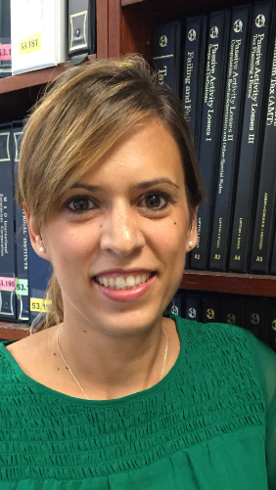

\

**JASMIN WELKER   
JURISTA**

**Asociacion de Abogados:** Alemania

**Idiomas:** Aleman, Ingles, Frances y Turco (conversacional)

**Educacion:** University of Erlangen-Nurnberg, Nurnberg, Germany, Second State Exam (JD) Jan 2012

**Experiencia:** Lex International law Firm,Miami, Florida, USA,

8/2016 – present

Jurist + German Attorney

**(**Contracts and Corporate Law, Immigration, real estate)

Sixt Rent a Car, LLC**,** Fort Lauderdale, USA

07/2013-11/2015

Contract and Concession Manager

(business, compliance, contracts, corporate)

Drager & Kollegen Law Firm,Bamberg, Germany

11/2012-06/2013

Attorney at Law (family, employment, inheritance, corporate law and litigation

Cenanovic Law Firm,Bamberg, Germany

09/2012-10/2012

Attorney at Law (employment, civil law and litigation)

Sparkasse, Nurnberg, Germany

01/2011-03/2011

Referendar (foreclosure law)

Lex International Law Firm, P.A.Miami, Florida, USA,

01/2011 – 03/2011

Referendar(immigration, corporate law, estate and trust, real estate)

Kreuzer & Coll, Law Firm**,** Nurnberg, Germany

03/2010-12/2010

Referendar (real estate)

**Areas de Practica:** Derecho Civil, Derecho de Contratacion, Negocios y Administracion.

**OFICINAS INTERNACIONALES**

**CANADA**

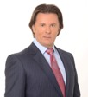 **JACQUES ETHIER**

**Admitt** **Asociacion de Abogados:** Québec, Canada 2004. (Practices in Canada)

**Idiomas:** Frances e Ingles

**Educacion:** Université de Sherbrooke (LLB), 2004; Université de Sherbrooke, Master Degree in Taxation (D. Fisc.), 2007; Accounting Degree (HEC Montreal), 1987.

**Miembro:** Canadian Bar Association; Fiscal and Financial Planning Association.

**Experiencia:** Leader of Enterprises among Ethier Holdings; Senior Tax lawyer at Ethier Lawyers; current President at Ethier Lawyers, Inc.; Leader of Enterprises at Ethier Lawyers, Montreal (Law Practice).

**Areas de Practica:** Derecho Empresarial, Finanzas Corporativas, Derecho Corporativo, Impuestos, Litigio Fiscal, Financiamiento Publico y Privado..

**FRANCIA**

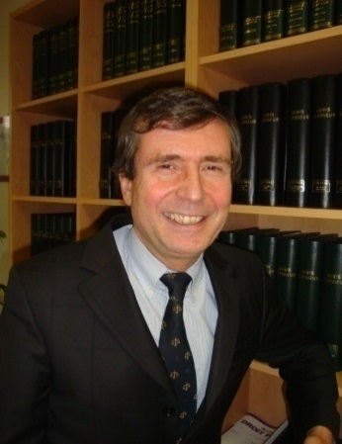

**ERIC J.P CITREY**

**Asociacion de Abogados:** Paris, France. (Practices in France)

**Idiomas**:Frances, Ingles e Italiano.

**Educacion**:University of Nice, France – Master of Public Law (1978); Diploma in Private International Law from l’Institut du Droit de la Paix et du Développement (1981), Memorandum: “L’Espace Judiciaire Européen” (The European Judicial Area); Doctor of Public and Private International Law (1983), Thesis: “Les Transferts de Capitaux entre la Communauté Economique Européenne et les Etats-Unis” (Capital Transfers Between the European Economic Community and the U.S.); University of Miami, LL.M (1983), Memorandum: “Exchange Contracts under I.M.F. Rules”.

**Experiencia**:Legal Counsel at Price Waterhouse, Paris (1987-1989), General Counsel at COFIREM Holding (1989-1990), In-house counsel at GEC ASLTHOM TRANSPORT S.A. (1990-1996).

**Honores**:Sachs Foundation (1982), Fulbright Scholarship (1983), Stark Scholarship (1983), Rotary International Scholarship (1984), Member of the French Committee of the International Chamber of Commerce.

**Areas de Practica**: Derecho Frances y Europeo, Derecho Comercial y de Negocios, Contratos Internacionales, Fusiones y Adquisiciones.

**BELGICA & LUXEMBURGO**

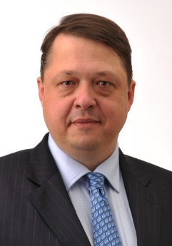 **OLIVIER HANCE**

**Asociacion de Abogados:** Belgica, Luxemburgo (Practica in Belgica & Luxemburgo)

**Idiomas:** Frances, Ingles e Italiano.

**Educacion:** Olivier holds a Master in Laws (UCL, Belgium), a Ph.D. in Law (Aix-Marseille, France), a two-year Executive MBA from Louvain School of Management (Belgium), Antai (Shanghai, China), Fundacao Getulio Vargas (Sao Paulo, Brazil) and Corvinius (Budapest, Hungary). Dr. Hance also graduated from numerous executive masters and programmes (INSEAD, Solvay, HEC Brussels, Tulane, etc.) in finance, real estate, wealth management, corporate governance and entrepreneurship.

**Miembror:** Belgian Bar Association; Bar of Luxembourg (list IV).

**Experiencia:** He has launched and managed various companies, sat in boards, been partner with Deloitte & Touche (with offices at Brussels, New York & Johannesburg) and served EU institutions. He has been teaching management and law in many universities over the past 20 years, notably the courses of “International Business Law” and an international seminar on “Private Equity as an Asset Class

**Areas de Practica:** Derecho Internacional, Derecho Comercial, Derecho Inmobiliario, Derecho Corporativo.

**RUSIA**

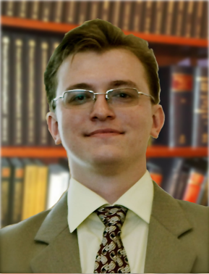

**ALEKSANDR SMIRNOV**

**Asociacion de Abogados:** Russian Federation (Practices in Russia)

**Idiomas:** Ruso e Ingles

**Educacion:** St. Petersburg State University Law School, Russia (2002)

**Experiencia:** Richwise Consulting Group (1998); ФГУП «Радиевый институт им. В.Г.Хлопина» - Госкорпорация РосАтом / Federal State Unitary Enterprise “V. Khlopin Radium Institute” RosAtom Corporation (2005-2010).

**Miembro:** Organizador del Seminario de la Asociacion de Negocios relacionados con temas de mediacion.

**Areas de Practica:** Derecho Corporativo, Derecho Fiscal Ruso e Internacional, Derecho Comercial, Arbitraje Nacional e Internacional, Regulacion Legal de Empresas Nacionales

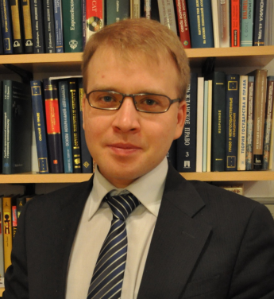

**VLADIMIR A. TROITSKIY**

**Asociacion de Abogados:** Federacion Rusa (Practica en Rusia)

**Idiomas:** Ruso, Ingles, Espanol y Aleman.

**Educacion:** Saint-Petersburg State University Law School (2002); Saint-Petersburg State University, Business School, Economics Department (2002); Saint-Petersburg State University Law School, PhD (2005).

**Publicaciones:** Autor de mas de 40 publicaciones, incluyendo: “The efficiency of International governmental organizations in transitional geopolitical conditions in the frameworks of international law progressive development tasks” published in Izvestia: Herzen University journal of humanities & sciences (N 104/2009, SPb); “Forms of economic integration of CIS states” (SPb. 2008); “International technical regulations in the states integration process” published in Izvestia: Herzen University journal of humanities & sciences (N 108/2010, SPb); “MERCOSUR experience of alternative arbitration procedure as a model for CIS. Actual problems of arbitration.” (Minsk, 2010); “Unification and harmonization of technical regulations as chief factor of interstate integration process. Research, development and application of high technologies in industry (SPb., 2010); “Implementation of international technical norms to the legislation of modern Russia” published in Customs academy bulletin (N3/2010); “Legal aspects of EurAsEC integration” published in History in development (SPb. 2010); “Comparative view on assimetric integration regulation in Common economic zone of Russia, Kazakhstan, Ukraine and Belorussia and EurAsEC” published in Problems of modern economy: Eurasian scientific review (N 2/2006).

**Experiencia:** Legal adviser and chief of law department of production and trade companies, CFO of holding company. Lawyer for City Invest Bank JSC in Saint-Petersburg, Russia (1999-2000). Head of legal department of City Invest Bank JSC in Saint-Petersburg, Russia, specialized in banking and corporate law, finance, taxation and investment law (2000-2001). Head of legal department of Universal-Contact Nets JSC. Saint-Petersburg, Russia, specialized in Corporate law, Intellectual property law, Patent law, International private law (2001-2002). Vice president of legal department and international relations of Universal-Contact Nets JSC. Saint-Petersburg, Russia, specialized in international relations. (2002-2003). Chief Financial Officer for UNI Oy. Helsinki, Finland, specialized in furniture design promotion, investments, patents and taxation (2003-2004). Vice president of Autocenter Pulkovo Ltd., specialized in external control, finance and tax law (2004-2006). CEO of Pulkovo-Auto Ltd., responsible for general management duties, development and finance (2004-2006). Senior partner of RichWise consulting group (2006-present). Professor of international private and public law, and law of international organizations at Saint-Petersburg State University.

**Miembro:** Member of expert council of Committee on the Commonwealth of Independent States Issues of The Council of Federation of Russia. Vice-president of Saint-Petersburg branch of UN association of Russia.

**Areas de Practica:** Derecho Internacional, Impuestos Rusos e Internacionales, Derecho Comercial y Arbitraje Ruso , Regulaciones Bancarias y Tecnicas.

**BRASIL**

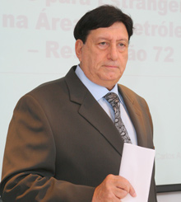

**CARLOS AUD SOBRINHO**

**Asociacion de Abogados:** Brasil. (Practica in Brasil)

**Idiomas:** portugues e Ingles

**Educacion:** Universidad Candido Mendes, Rio de Janeiro, Doctorado en Derecho Internacional

**Experiencia:** Current President at CAS Oil Visas. A leader in the area of immigration, CAS prepares a strategic and effective recruitment and transfer of skilled foreign labor in Brazil, regulating the foreign collaborators who are uncertain about the legislation and laws. CAS has 38 years of experience and knowledge to meet the needs of our clients. Dr. Carlos Aud Sobrinho, the C.E.O. of CAS and a professional with the most years of experience in the immigration area, shows that CAS does what it promises, with complete quality and guaranteed deadlines.

**Areas de Practica:** Derecho Internacional, Derecho de inmigracion.

.

**REPUBLICA DOMINICANA**

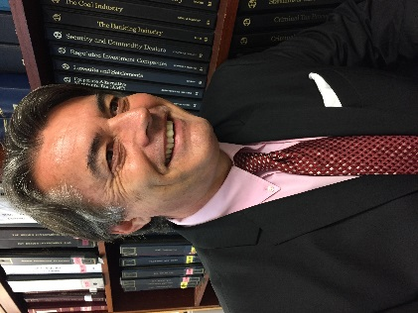

**ERIC VIGNERON**

**Asociacion de Abogados:** French Lawyer, French Bar (1988-1995); Dominican Republic (Bar of Santo Domingo) Bar of Quebec (Canada)

**Idiomas:** Frances, Ingles y Espanol.

**Educacion:** Master Law in France (University of Dijon); Master Law in Dominican Republic UASD; Equivalency Master Law LLM USA;

**Publicaciones:** *Divorce en 48h.* [*www.village*](http://www.village) *justice.com/articles/DIVORCE,12396.html.; Une niche fiscale dont personne ne parle-* [*www.village-justice.com/articles/niche-fiscale-personne-parle,8882.html*](http://www.village-justice.com/articles/niche-fiscale-personne-parle,8882.html)*; Une niche fiscale dont personne ne parle-* [*www.village-justice.com/articles/niche-fiscale-personne-parle,8882.html*](http://www.village-justice.com/articles/niche-fiscale-personne-parle,8882.html)*; L’exonération fiscale totale en dehors des paradis fiscaux…* [*www.village-justice.com/.../exoneration-fiscale-totale-dehors,4504.html*](http://www.village-justice.com/.../exoneration-fiscale-totale-dehors,4504.html)*; La fiscalité des énergies renouvelables, par Eric Vigneron* [*www.village-justice.com/.../fiscalite-energies-renouvelables,7864.html*](http://www.village-justice.com/.../fiscalite-energies-renouvelables,7864.html)*; Impôts locaux motivation obligatoire du rehaussement…* [*www.village-justice.com/.../Impots-locaux-motivation-obligatoire,11272*](http://www.village-justice.com/.../Impots-locaux-motivation-obligatoire,11272)*...; Une reforme fiscale 2010 portant atteinte aux défenses* [*www.village.justice.com/.../reforme-fiscale-portant-atteinte,7863.html*](http://www.village.justice.com/.../reforme-fiscale-portant-atteinte,7863.html)*; Nouveau : la « blue card » et non la « green card »- Village de …* [*www.village.justice.com/.../Nouveau-green-travailler-france,12635.html*](http://www.village.justice.com/.../Nouveau-green-travailler-france,12635.html)*; Succession :* [*http://frenchdistrict.com/floride/articles/reforme-juridique-successions-internationales-maitre-eric-vigneron/*](http://frenchdistrict.com/floride/articles/reforme-juridique-successions-internationales-maitre-eric-vigneron/)*; Book « paradis fiscaux mythe ou réalité »* [*https://ww.amazon.fr/Paradis-Fiscaux-Andre-Gueugnon/dp/274831502*](https://ww.amazon.fr/Paradis-Fiscaux-Andre-Gueugnon/dp/274831502)*; https://facebook.com/dominicana.visa;*

**Experiencia:** French Fiduciary tax adviser; Tax adviser for Public Accounting Firm F.W.I; Professor of Corporate Law in Bourgogne University (1994, France)

**Miembreo:** UIA (Union International of Lawyers); ABA (American Bar Association);

**Areas de Practica:** Derecho Corporativo; Derecho Tributaria; la observancia pública; Derecho Fiscal Internacional; FATCA; tratados fiscales internacionales; la confianza de la comunidad internacional y la planificación de sucesiones. Las transacciones comerciales internacionales; y contratos corporativos generales; Derecho Internacional de Inversiones Extranjeras



**www.lex-international.com**

**lex@lex-international.com**

**lex1usa@aol.com**